Ideation Phase
Brainstorm & Idea Prioritization

Date | 5 September 2026
Student Name | Bantupalli Niharika
Project Name | Automated Network Request Management
Maximum Marks

Brainstorm & Idea Prioritization
The project brainstorm focuses on creating a centralized ServiceNow-based network request management system for handling network-related requests such as Wi-Fi, LAN, VPN, and other connectivity services. The solution focuses on structured request data capture, guided submission, dynamic form behavior, approval management, automated task creation, assignment, notifications, and future reporting.
Idea | Group | Priority
Service Catalog | User Request Management | High
Network Request Catalog Item | User Request Management | High
Custom Network Database Table | Data Management | High
Network Task Table | Task Management | High
Catalog Variables | Structured Data Capture | High
Catalog UI Policies | User Experience | High
Approval Automation | Workflow Automation | High
Automated Network Task Creation | Workflow Automation | High
Assignment to Network Fulfillment Team | Task Management | High
Email Notifications | Communication | Medium
Request Status Tracking | Monitoring | High
Reports and Dashboards | Analytics | Medium

Brainstorm & Idea Prioritization
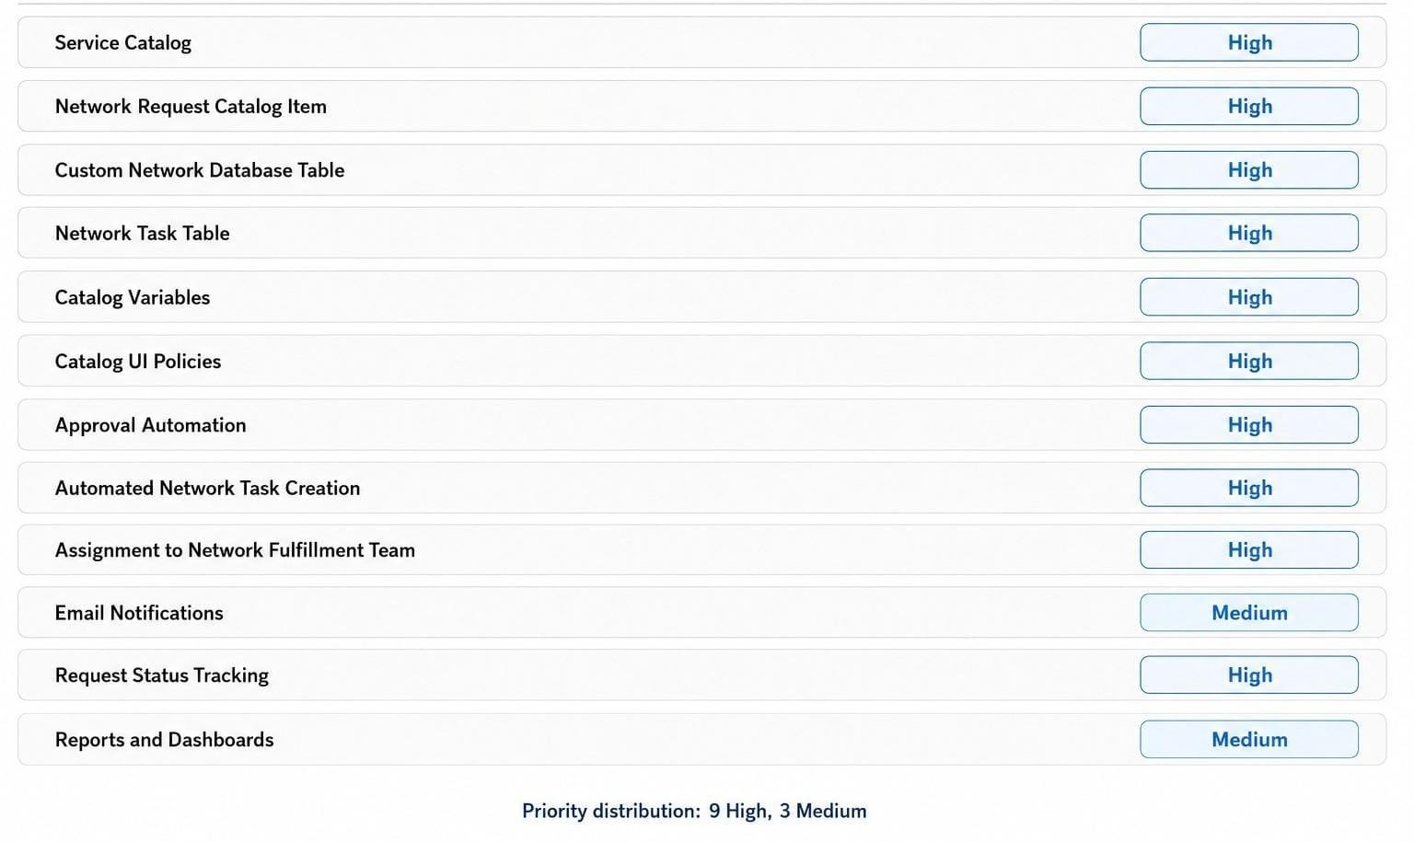
Figure 1: Prioritized brainstorm representation based on the project ideas.

